**Recipe CRUD App**

In this project, you will build a Recipe tracking app. The app will allow a user to add new recipes, display a list of recipes and delete a recipe from the list by clicking a delete button. You will also be asked to add styling as provided in the mockup.

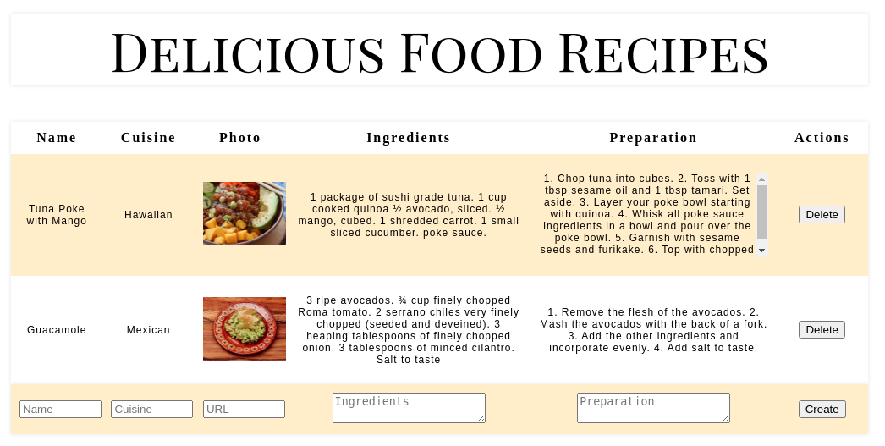

This project has starter code you can use for the application. You will need to add handlers and other logic to make this code work.

**Specific Instructions**

Find the TODO comments in the code and create the necessary functionality. Below is a list of specific items you will need to complete for this checkpoint.

* App will display a recipe's name, cuisine, photo, ingredients, preparation instructions and action buttons (edit and delete).
* Create at least one additional component that is used by the RecipeList component.
* It does not need to match the exact appearance of the mockup, but should be similar and pass the styling tests.
* Add handlers and other attributes to the starter code as needed.

To create a recipe entry, your app will need to have a form with input fields for the name of the dish, the cuisine it belongs to, and an URL that points to a picture of the dish. Use <textarea> for the ingredients and preparation. For the tests to pass, use the following names for your inputs: <input name="name">, <input name="cuisine">, <input name="photo">, <textarea name="ingredients"> and <textarea name="preparation">.

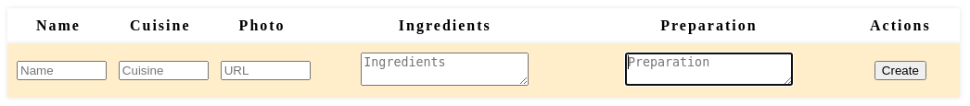

To read and display the list of recipes use the table structure that we provide in the starter code. Each recipe should display the name, cuisine, photo, ingredients, preparation and a delete button as shown below:

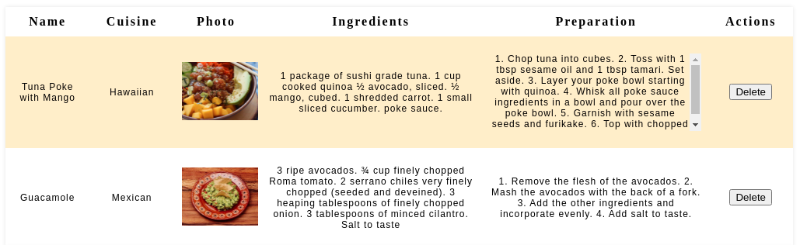

Clicking the delete button should remove the entire row/recipe from the list. For the tests to pass, make sure that the delete button has delete as a name value (name="delete"). e.g. <button name="delete" onClick={deleteRecipe}>Delete</button>.

**Styling Instructions**

The Delicious Food Recipes text surrounded by an h1 tag should use the 'Playfair Display SC' font that has already been imported in App.css. It should also be centered and have a size of 64px.

Read [the documentation for nth-child](https://developer.mozilla.org/en-US/docs/Web/CSS/:nth-child). Use nth-child to set the width of the columns. We suggest setting the width for the *preparation* and *ingredients* columns to 30%. For the rest of the columns, set the width to 10%.

Use nth-child(odd) to set the table's *zebra striping* color pattern for the rows in tbody. The color in the mockup is #fff0c7 but feel free to use a color of your preference that suits the design.

The *preparation* and *ingredient* columns should display a scrollbar if there is too much text. Use the predefinedcontent_td class and p tag to wrap the text so that it uses a scrollbar if the text is too long (e.g. <td className="content_td"><p>{(recipe.ingredients)}</p></td> ).

Use the [object-fit](https://developer.mozilla.org/en-US/docs/Web/CSS/object-fit) property to scale-down the images and set the image width and height to 100%.

**Success Criteria**

* Functionality:
  + User can create a recipe entry.
  + User can read the list of recipes.
  + User can delete a recipe.
  + CSS is used to make the app look like the mockup.
* React Code Organization:
  + Uses multiple components that play well together
  + Recipe data is contained in the state.
* General Code Organization:
  + Minimal code duplication